|  |  |
| --- | --- |
| **22bec121** |  |
| **Experiment – 5** | **Date:-15/2/2024** |

**Lab Work**

**Q1 .Post Lab Exercises**

# Code (Generated)

module snehexp5(

Mode,

CLK,

HIGH,

Q3,

Q2,

Q1,

Q0

);

input wire Mode;

input wire CLK;

input wire HIGH;

output reg Q3;

output wire Q2;

output wire Q1;

output wire Q0;

wire SYNTHESIZED_WIRE_0;

wire SYNTHESIZED_WIRE_1;

wire SYNTHESIZED_WIRE_2;

reg JKFF_A;

reg JKFF_2;

reg JKFF_3;

assign Q2 = JKFF_3;

assign Q1 = JKFF_2;

assign Q0 = JKFF_A;

always@(posedge SYNTHESIZED_WIRE_0)

begin

JKFF_2 <= ~JKFF_2 & HIGH | JKFF_2 & ~HIGH;

end

always@(posedge SYNTHESIZED_WIRE_1)

begin

JKFF_3 <= ~JKFF_3 & HIGH | JKFF_3 & ~HIGH;

end

always@(posedge SYNTHESIZED_WIRE_2)

begin

Q3 <= ~Q3 & HIGH | Q3 & ~HIGH;

end

always@(posedge CLK)

begin

JKFF_A <= ~JKFF_A & HIGH | JKFF_A & ~HIGH;

end

assign SYNTHESIZED_WIRE_0 = Mode ^ JKFF_A;

assign SYNTHESIZED_WIRE_1 = Mode ^ JKFF_2;

assign SYNTHESIZED_WIRE_2 = Mode ^ JKFF_3;

endmodule

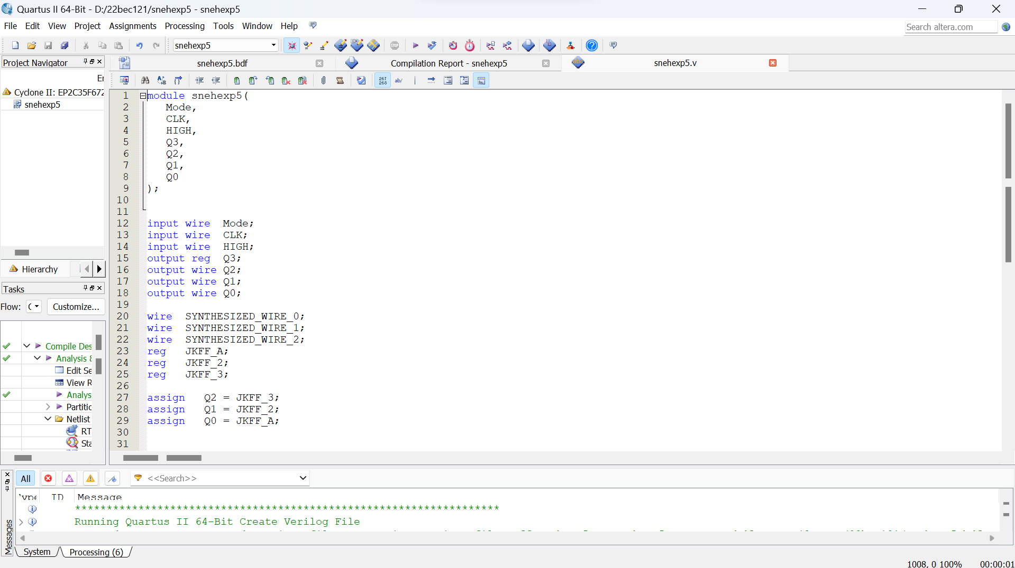

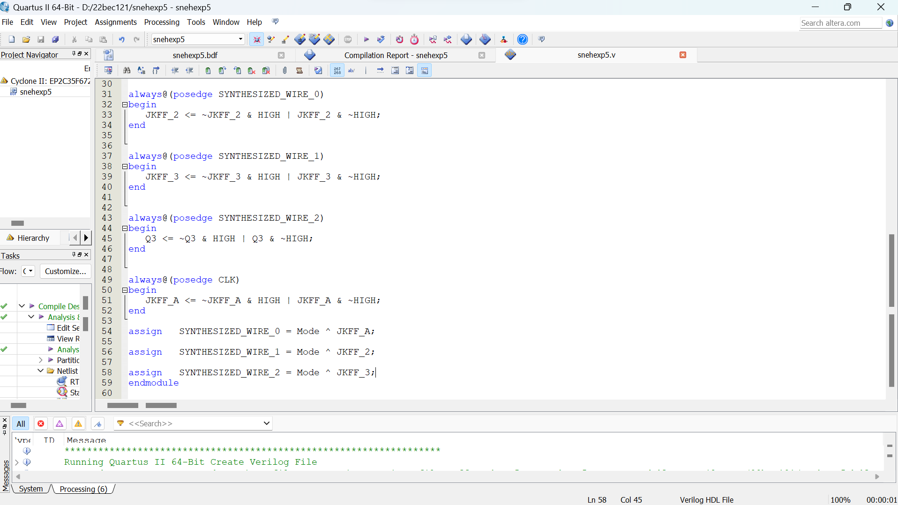

**Block Design**

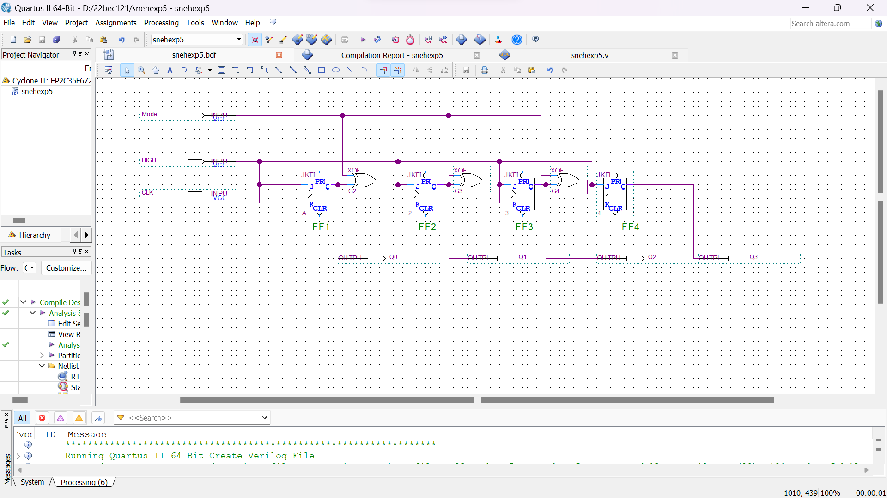

# Output 1)Cyclone II (RTL View)

# 

**2)Cyclone II (TTL View)**

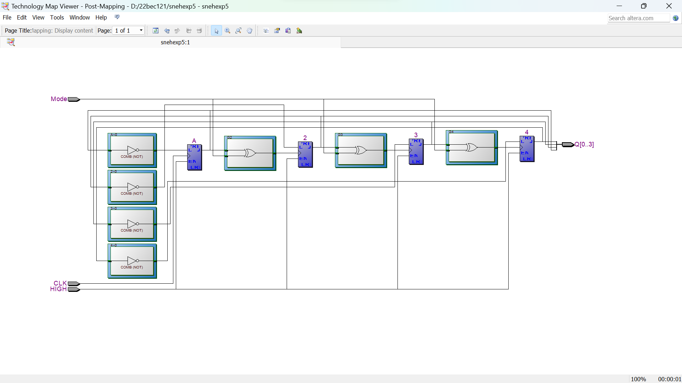

**Conclusion :- In this experiment we learnt that how we can implement any circuit using Block Diagrams .**

**This is a tedious way to implement a circuit but it is a way to develop small circuits with ease .**

**We also generated Verilog Code from the Block Diagram to implement a 4 bit Up/Dow Counter .**